Chapter 4 Questions for Miss Peregrine’s Home for Peculiar Children
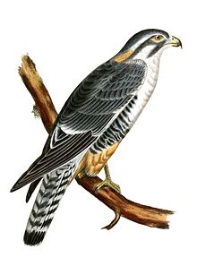
This Photo by Unknown Author is licensed under CC BY-SA
- How does Jacob know his father is about to give him his full attention? What does this say about their relationship?

- Why does Jacob’s father think Grandpa Portman traveled so often? What physical evidence did he find to support his theory?

- What does the quote, “Because if Grandpa Portman wasn’t honorable and good, I wasn’t sure anyone could be,” (92) say about his feelings toward his grandfather?

- What happened to the house on the hill?

- How did the people of Cairnholm feel about the “orphan children” who lived in the house?

- What day did the bombing happen? Why is this day significant?

- Why is Jacob’s father angry at the new knowledge Jacob discovers about his grandfather from Oggie?

- Jacob’s father refers to Grandpa Portman as “an emotional Fort Knox” (101). What does he mean by this?

- Why does Jacob’s father think Grandpa Portman and Jacob were so close?

- What disturbs Jacob about the letter Miss Peregrine sent his grandfather?

- Why does Jacob decide to go back to the house?

- How does Jacob’s character develop in this chapter? What specific aspects in the chapter lead to Jacob developing as a character/hero?

